Intro to SQL Commands - TCL

✅ What is SQL Commands – TCL (Transaction Control Language)?
# Source: AI Source: Provided by: [Data Path: Persons Table -> ID Column: 1, Name_En Column: Motasem Essam] -> From: [ChatGPT] on [6/11/2026]
TCL stands for Transaction Control Language. These commands are used to manage transactions — units of work that are executed together — and control whether changes made by DML operations (INSERT, UPDATE, DELETE) are saved or undone.

✅ What is a Transaction in SQL?
# Source: AI Source: Provided by: [Data Path: Persons Table -> ID Column: 1, Name_En Column: Motasem Essam] -> From: [ChatGPT] on [6/11/2026]
A transaction is a sequence of one or more SQL statements that are executed as a single logical unit of work.
It ensures that a group of operations either all succeed or all fail — never left halfway.

🔐 Key Purpose:
# Source: AI Source: Provided by: [Data Path: Persons Table -> ID Column: 1, Name_En Column: Motasem Essam] -> From: [ChatGPT] on [6/11/2026]
- To maintain data integrity
- To handle multiple changes safely and consistently (especially in multi-user environments)

🧩 Example Scenario (Bank Transfer):
# Source: AI Source: Provided by: [Data Path: Persons Table -> ID Column: 1, Name_En Column: Motasem Essam] -> From: [ChatGPT] on [6/11/2026]
Suppose you're transferring $100 from Account A to Account B:
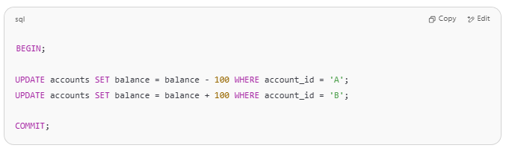
BEGIN;

UPDATE accounts SET balance = balance - 100 WHERE account_id = 'A';
UPDATE accounts SET balance = balance + 100 WHERE account_id = 'B';

COMMIT;

If anything goes wrong (e.g., power failure), you can:
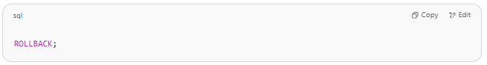
ROLLBACK;

This ensures money isn't lost or duplicated. ✅

📘 Properties of a Transaction (ACID):
# Source: AI Source: Provided by: [Data Path: Persons Table -> ID Column: 1, Name_En Column: Motasem Essam] -> From: [ChatGPT] on [6/11/2026]
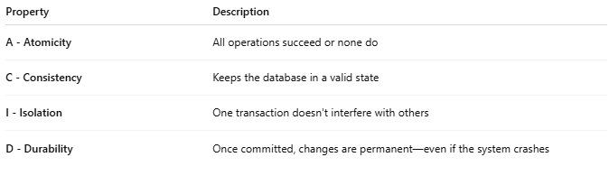
Property | Description
A - Atomicity | All operations succeed or none do
C - Consistency | Keeps the database in a valid state
I - Isolation | One transaction doesn't interfere with others
D - Durability | Once committed, changes are permanent—even if the system crashes

🔧 Transaction Flow:
# Source: AI Source: Provided by: [Data Path: Persons Table -> ID Column: 1, Name_En Column: Motasem Essam] -> From: [ChatGPT] on [6/11/2026]
- BEGIN / START TRANSACTION
- Do your INSERT, UPDATE, DELETE statements
- Decide:
  - Use COMMIT to save changes
  - Use ROLLBACK to undo if there's an error

✅ Summary:
# Source: AI Source: Provided by: [Data Path: Persons Table -> ID Column: 1, Name_En Column: Motasem Essam] -> From: [ChatGPT] on [6/11/2026]
A transaction = a safe group of SQL operations that should happen together or not at all.
Let me know if you want to practice with sample transaction scripts or error-handling cases.

🧩 Core TCL Commands:
# Source: AI Source: Provided by: [Data Path: Persons Table -> ID Column: 1, Name_En Column: Motasem Essam] -> From: [ChatGPT] on [6/11/2026]
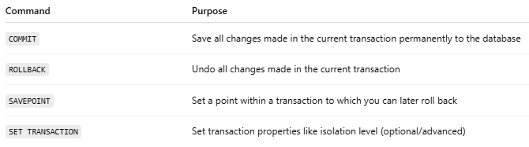
Command | Purpose
COMMIT | Save all changes made in the current transaction permanently to the database
ROLLBACK | Undo all changes made in the current transaction
SAVEPOINT | Set a point within a transaction to which you can later roll back
SET TRANSACTION | Set transaction properties like isolation level (optional/advanced)

📘 Examples:

🔹 COMMIT
# Source: AI Source: Provided by: [Data Path: Persons Table -> ID Column: 1, Name_En Column: Motasem Essam] -> From: [ChatGPT] on [6/11/2026]
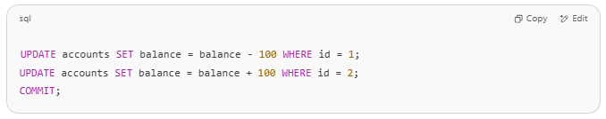
UPDATE accounts SET balance = balance - 100 WHERE id = 1;
UPDATE accounts SET balance = balance + 100 WHERE id = 2;
COMMIT;

→ Both updates are saved.

🔹 ROLLBACK
# Source: AI Source: Provided by: [Data Path: Persons Table -> ID Column: 1, Name_En Column: Motasem Essam] -> From: [ChatGPT] on [6/11/2026]
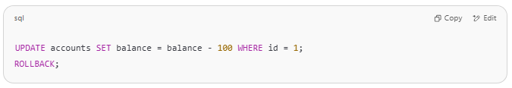
UPDATE accounts SET balance = balance - 100 WHERE id = 1;
ROLLBACK;

→ The change is undone.

🔹 SAVEPOINT
# Source: AI Source: Provided by: [Data Path: Persons Table -> ID Column: 1, Name_En Column: Motasem Essam] -> From: [ChatGPT] on [6/11/2026]
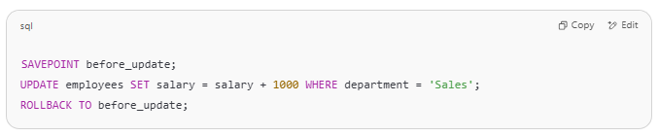
SAVEPOINT before_update;
UPDATE employees SET salary = salary + 1000 WHERE department = 'Sales';
ROLLBACK TO before_update;

→ Only the salary update is undone, not the whole transaction.

⚠️ When to Use TCL
# Source: AI Source: Provided by: [Data Path: Persons Table -> ID Column: 1, Name_En Column: Motasem Essam] -> From: [ChatGPT] on [6/11/2026]
- During financial or batch processing
- When multiple dependent queries must be treated as one unit
- When rollback is needed on failure

✅ Key Points:
# Source: AI Source: Provided by: [Data Path: Persons Table -> ID Column: 1, Name_En Column: Motasem Essam] -> From: [ChatGPT] on [6/11/2026]
- TCL is used with DML to control data integrity.
- If you run INSERT, UPDATE, or DELETE without COMMIT, changes can be rolled back.
- It's important in systems where data accuracy and consistency matter (e.g., banking, e-commerce).

